**服务器需求**

所有分类如下

大类 小类

格斗类：武术 跆拳道 空手道 泰拳 拳击

大球类：足球 篮球 排球 水球 棒球 橄榄球 冰球

舞蹈类：现代舞 拉丁舞 街舞 芭蕾 钢管舞

小球类：羽毛球 保龄球 乒乓球 高尔夫 壁球 桌球 轻排球

健身类：健身 瑜伽 游泳

儿童类：欢乐天地 室外游乐 充气城堡

其他类：射箭 攀岩 滑冰 击剑 极限运动 沙壶球

客户端用户选择分类后提供索引信息及手机经纬度信息给服务器

索引提交服务器数据如下

{

"Type": "格斗类",

"Subdivision": "武术",

"Longitude": 100,

"Latitude": 100

}

服务器按照数据库中工作室的经纬度距离由近到远返回工作室列表信息，并根据经纬度换算成距离，单位“米”,并给出该工作室的访问量和购买次数

服务器返回数据如下

{

"Studio_1": {

"StudioID": 1,

"StudioName": "波恩健身",

"Distance": 300,

"Visit": 10000,

"Buy": 100

},

"Studio_2": {

"StudioID": 1,

"StudioName": "波恩健身",

"Distance": 300,

"Visit": 10000,

"Buy": 100

}

}

客户端的搜索效果如下

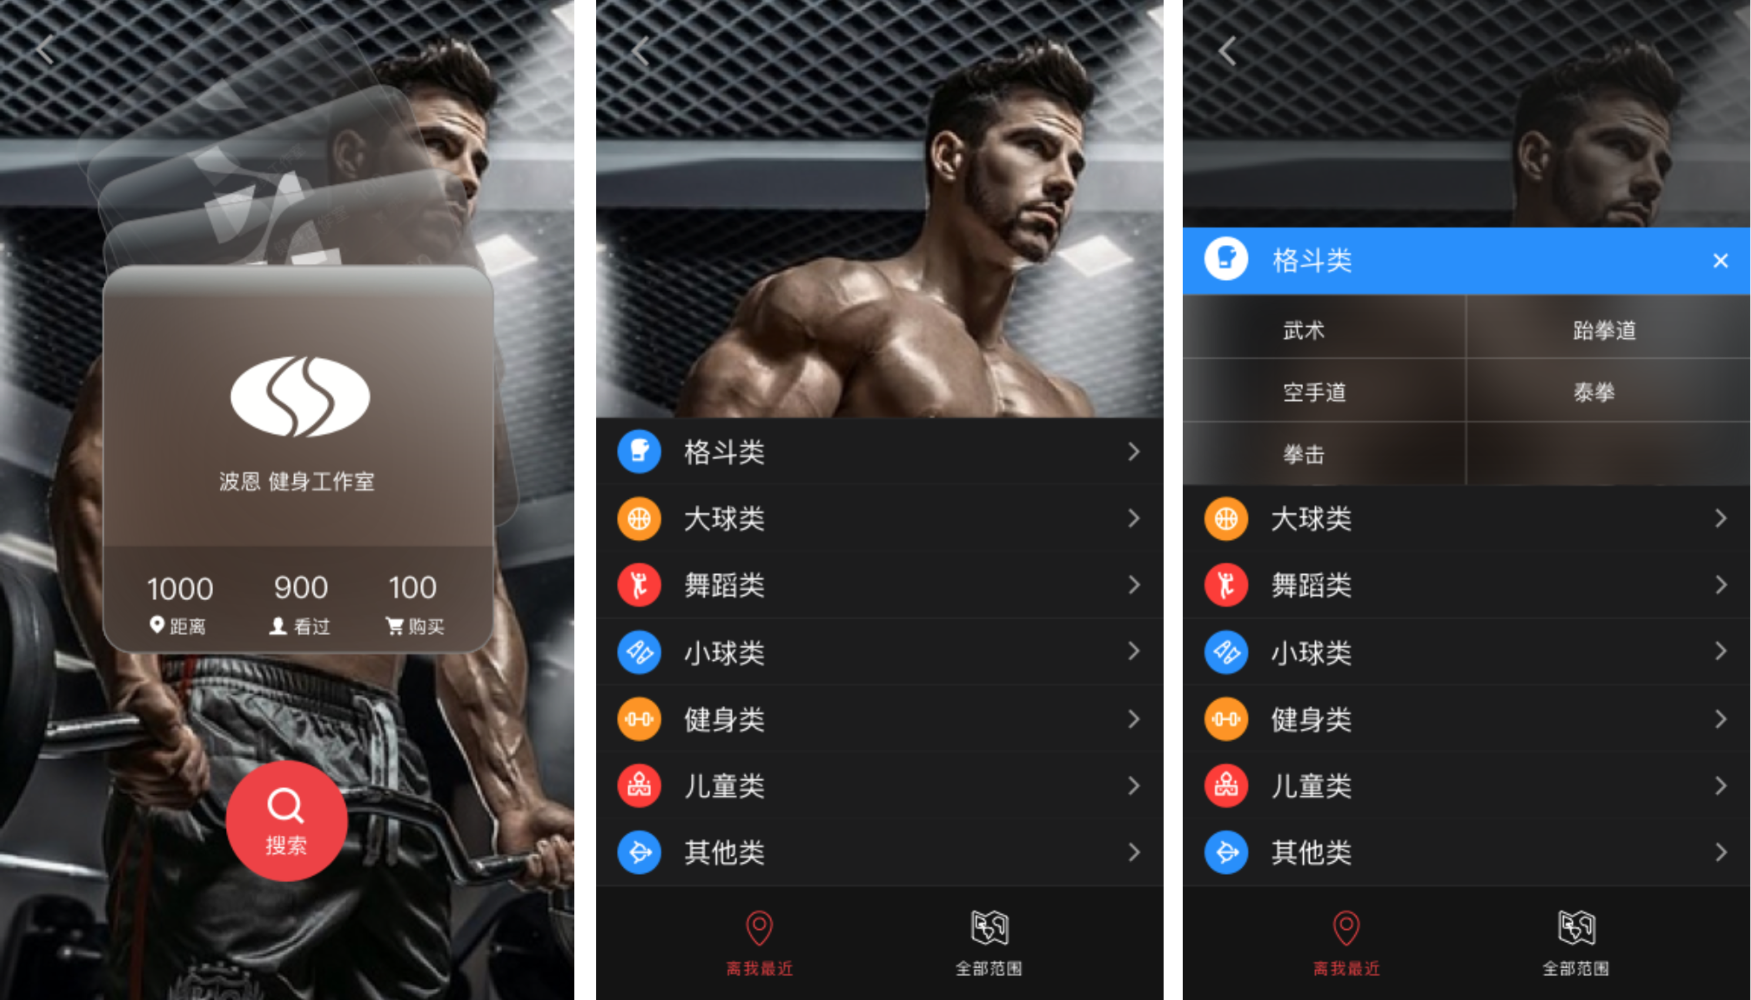

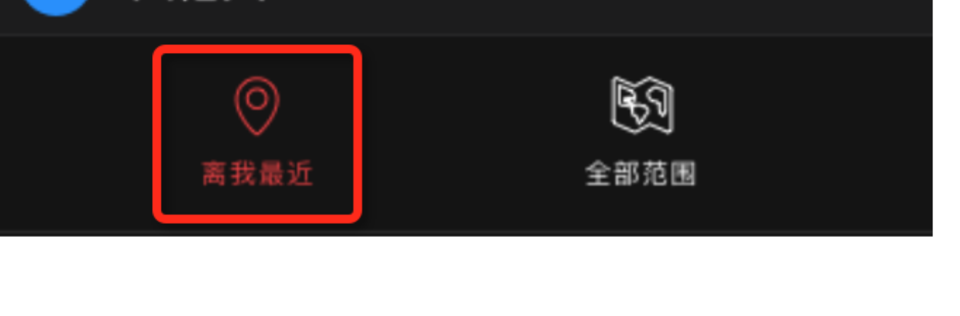

需要服务端有个数据库，记录每个商户的详细信息，信息如下（内容都是测试的）

其中：StudioID 为每个工作室ID，此ID唯一；Coordinate字段记录经纬度

{

"StudioData": {

"StudioType": "格斗类",

"Subdivision": "武术",

"StudioID": 1,

"StudioName": "波恩健身",

"StudioLogo": "/Volumes/EX/UnityProject/XingVRScene/AllTestData/健身房LOGO/波恩LOGO_03.png",

"StudioInfo": {

"Info": "TestTestTestTestTestTestTestTestTestTestTestTestTestTestTestTestTestTestTestTestTestTestTestTestTestTest",

"Phone": 13900000000,

"isParking": true,

"isWifi": true,

"OpenTime": "6点-21点",

"Star": 5,

"Address": {

"Province": "上海",

"City": "上海市",

"Area": "徐汇区",

"Road": "漕溪路",

"No": 1000,

"Coordinate": {

"Longitude": 100,

"Latitude": 100

}

}

},

"VRData": {

"Data1": {

"RoomName": "Room1",

"VRViewPhoto": "http://www.xingfit.com/panorama/studio_1/1.pic_hd.jpg",

"Advertising": "https://ss0.bdstatic.com/5aV1bjqh_Q23odCf/static/superman/img/logo/bd_logo1_31bdc765.png",

"Preview": "https://ss0.bdstatic.com/5aV1bjqh_Q23odCf/static/superman/img/logo/bd_logo1_31bdc765.png",

"Exit": {

"Exit1": {

"PositionAngle": 50,

"GotoScene": 0

},

"Exit2": {

"PositionAngle": 180,

"GotoScene": 0

}

}

},

"Data2": {

"RoomName": "Room1",

"VRViewPhoto": "http://www.xingfit.com/panorama/studio_1/2.pic_hd.jpg",

"Advertising": "https://ss0.bdstatic.com/5aV1bjqh_Q23odCf/static/superman/img/logo/bd_logo1_31bdc765.png",

"Preview": "https://ss0.bdstatic.com/5aV1bjqh_Q23odCf/static/superman/img/logo/bd_logo1_31bdc765.png",

"Exit": {

"Exit1": {

"PositionAngle": 60,

"GotoScene": 0

}

}

}

},

"Activity": {

"Preview": "https://ss0.bdstatic.com/5aV1bjqh_Q23odCf/static/superman/img/logo/bd_logo1_31bdc765.png",

"Title": "活动1",

"Date": "2016年1月1日",

"Url": "https://www.baidu.com"

},

"ManagerRecommend": {

"Video": "http://wq.xingfit.com/voute/video/Boom.mp4",

"Info": "TestTestTestTestTestTestTestTestTestTestTest",

"Photo": [

"https://ss0.bdstatic.com/5aV1bjqh_Q23odCf/static/superman/img/logo/bd_logo1_31bdc765.png",

"https://ss0.bdstatic.com/5aV1bjqh_Q23odCf/static/superman/img/logo/bd_logo1_31bdc765.png"

]

},

"CoachData": {

"Name": "黄教练",

"Icon": "https://ss0.bdstatic.com/5aV1bjqh_Q23odCf/static/superman/img/logo/bd_logo1_31bdc765.png",

"Info": "Test Test Test Test Test Test Test Test",

"Photo": "https://ss0.bdstatic.com/5aV1bjqh_Q23odCf/static/superman/img/logo/bd_logo1_31bdc765.png",

"BuyUrl": "http://m.dianping.com/mobile/event/63868",

"Ability": {

"Cost": 0,

"Stamina": 0,

"Speed": 0,

"Patient": 0,

"Experience": 0,

"Professional": 0

}

}

}

}